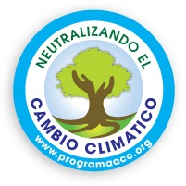

Buy a Tree
PURCHASE FORM
Corresponds to mandatory fields*
Data of who gives
Name*
Last name
Email *
Number of trees to buy *

Data of who will receive the gift
Name *
Last name
Email *
Certificate Date *
Certificate Code *

Name in memory of (only Code 4AE)

Please send the payment image (Paypal, or credit card ...) and this purchase form to the email: info@programaacc.org
to send you the certificate and the link.

On the next page you can see the available certificate designs.

Thank you!

